Unit -1

History of Web and Internet

**M. Mitchell Waldrop’s book, *“The Dream Machine.”***

1. The history really begins with the Arpanet, created by the Information Processing Techniques Office (IPTO) in the Advanced Research Projects Agency (ARPA), part of the U.S. Dept. of Defense. Bob Taylor, who had come to ARPA from NASA in 1965, got the idea for a network by observing that each working group that was doing IPTO-funded research had its own time-sharing service, and that each used an incompatible communication protocol that required the IPTO to use a different terminal for each group. The different working groups couldn’t communicate with each other directly. They had to relay messages to each other through the staff at the IPTO.

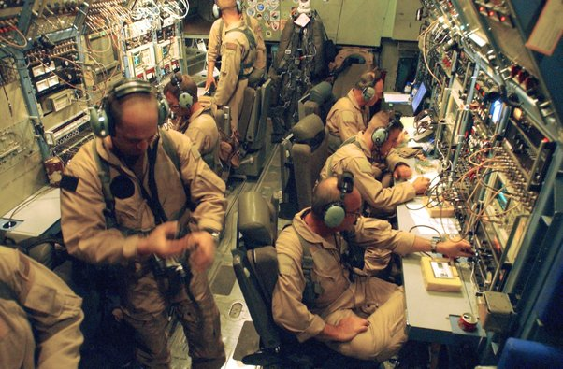

Wes Clark, who had joined ARPA a couple years earlier, hit upon an analogy of interchanges between highways. He suggested that the network use dedicated computers just for routing packets. Roberts liked this idea better, and so the network incorporated network switches (also commonly called “routers” today). They were called Information Message Processors (IMPs).

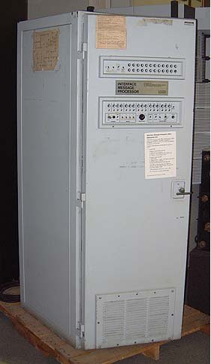

In the 1970s, ARPANET expanded and adopted the TCP/IP protocol suite, laying the foundation for the modern Internet. During this time, email and other early internet applications were developed, enabling communication and information sharing across the network.

Time line of internet

Link 1: https://www.slideshare.net/annabelayson/activity-10-timeline-history-of-internet-31423239#1

Evolution of Web:

The web that we know today has seen many phases, broadly categorized into three phases - Web 1.0, Web 2.0, and Web 3.0.

Let's dive a little deeper and discover how the web evolved from its inception to what we know it as now.

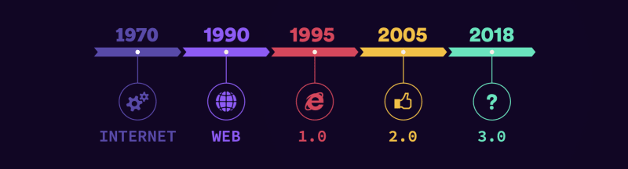

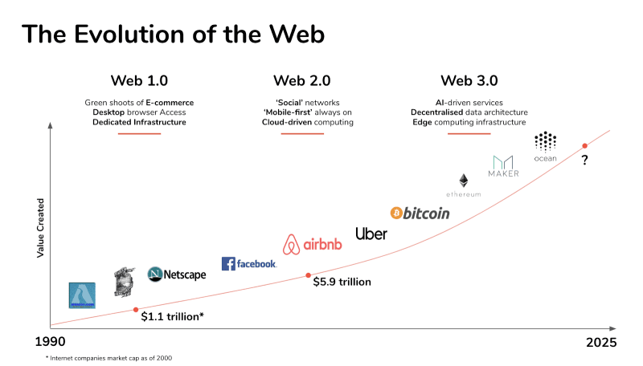

**Web 1.0**

Web 1.0 was the first stage of the World Wide Web revolution, usually referred to as **read-only web**. This was how the Internet we know today started in the first place, where the websites were merely informational and comprised entirely static content; they were only linked together by hyperlinks and lacked any interactive content or design elements.

This was the era when only text emails could be written and sent, one could not even upload or attach any images or pictures.

## Web 2.0

Web 2.0 was the second stage of the evolution of the web, also called the **read-write web** and it was the phase when websites grew in terms of user interaction. It was the period when websites became more focused on user-generated content, usability, and interoperability for end-users, leading them to become the - **participative social web**.

During Web 2.0, terms like blogs, social media, and video streaming gained popularity. This time period is also acknowledged for the ease with which music and video clips could be exchanged. It opened doors to podcasting, blogging, tagging, curating with RSS, social bookmarking, social networking, social media, web content voting, etc. It was the birthplace of YouTube, Wiki, Flickr, Facebook, and so on.

PHP & MySQL-led blogging platform and has now advanced to become a full content managed system (CMS) which powers over a quarter of the web and e-Commerce completely revolutionized the way we shop.

Thus, Web 2.0 brought a fundamental shift where people were allowed to share their perspectives, opinions, thoughts, and experiences via a number of online tools and platforms. It brought us the concept - **' Web as Platform '**, where software applications are built upon the Web as opposed to upon the desktop. This was when websites began using web browser technologies such as AJAX and JavaScript frameworks. This period continued to see the origin of APIs (Application Programming Interface) - a software intermediary that allows two applications to communicate with one another.

## Web 3.0

Web 3.0 is the next generation of web, also termed as the **executable web** or **read- write-execute** web. It began with the onset of dynamic applications, interactive services, and “machine-to-machine” interaction. It is used to describe many evolutions of web usage and interaction between various paths. Data is not owned in this case, but rather shared, with services displaying different views for the same web/data.

LINK2: https://medium.com/fulldive/a-brief-history-of-browsers-9e8f453dbf45

Internet tools and services:

Link : https://arato.inf.unideb.hu/fazekas.gabor/english/Tools_Of_Internet/READINGS/2011-0103_08_internet_tools_and_services-1.pdf

The Internet covers large, international Wide Area Networks (WAN‘s) as well as smaller Local Area Networks (LAN‘s) and individual computers connected to the Internet worldwide. The Internet supports communication and sharing of data, and offers vast amount of information through a variety of services and tools. The major

Internet tools and services are:

• Electronic mail (email)

• Newsgroups

• Internet Relay Chat (IRC)

• Telnet and SSH

• File Transfer Protocol (FTP and FTPS, SFTP)

• World Wide Web (www)

**Electronic mail,** most commonly referred to as email or e-mail since ca. 1993, is a method of exchanging digital messages from an author to one or more recipientsE-mail clients allow you to send and receive electronic mail messages. To use e-mail on the Internet, you must first have access to the Internet and an e-mail account set up (mostly free of charge) that provides you with an e-mail address. Valid e-mail address consists of a username and a domain name separated by the @ sign. An email message consists of three components: the message envelope, the message header, and the message body. The message header contains control information, including, minimally, an originator's email address and one or more recipient addresses. Usually descriptive information is also added, such as a subject header field and a message submission date/time stamp. Network-based email was initially exchanged on the ARPANET in extensions to the File Transfer Protocol (FTP), but is now carried by the Simple Mail Transfer Protocol (SMTP), first published as Internet standard 10 (RFC 821) in 1982. In the process of transporting email messages between systems, SMTP communicates delivery parameters using a message envelope separate from the message (header and body) itself.

**Newsgroups** are often arranged into hierarchies, theoretically making it simpler to find related groups. The term top-level hierarchy refers to the hierarchy defined by the prefix before the first dot. The most commonly known hierarchies are the Usenet hierarchies. Usenet is a news exchange service similar to electronic bulletin boards. Usenet is older than the Internet, but the two are commonly associated with one another since most Usenet traffic travels over the Internet. A Usenet newsgroup is a repository usually within the Usenet system, for messages posted from many users in different locations. The term may be confusing to some, because it is in fact a discussion group. In recent years, this form of open discussion on the Internet has lost considerable ground to browser-accessible forums and social networks such as Facebook or Twitter

**Internet Relay Chat (IRC)** allows you to pass messages back and forth to other IRC users in real time, as you would on a citizens' band (CB) radio. It is mainly designed for group communication in discussion forums, called channels, but also allows one-to-one communication via private message as well as chat and data transfer. IRC is an open protocol that uses TCP. An IRC server can connect to other IRC servers to expand the IRC network. Users access IRC networks by connecting a client to a server. The standard structure of a network of IRC servers is a tree. Messages are routed along only necessary branches of the tree.

**Telnet** allows you to log into another computer system and use that system's resources just as if they were your own. Telnet was developed in 1969 beginning with RFC 15, extended in RFC 854, and standardized as Internet Engineering Task Force (IETF) Internet Standard STD 8, one of the first Internet standards. However, because of serious security issues when using Telnet over an open network such as the Internet, its use for this purpose has waned significantly in favor of SSH (Secure Shell). SSH uses public-key cryptography to authenticate the remote computer and allow it to authenticate the user. File Transfer Protocol (FTP) is a standard network protocol used to transfer files from one host to another host over a TCP-based network, such as the Internet.

**FTP** is built on a client-server architecture and uses separate control and data connections between the client and the server. FTP users may authenticate themselves using a clear-text sign-in protocol, normally in the form of a username and password, but can connect anonymously if the server is configured to allow it. For secure transmission that hides (encrypts) the username and password, and encrypts the content, FTP is often secured with SSL/TLS ("FTPS"). SSH File Transfer Protocol ("SFTP") is sometimes also used instead, but is technologically different and based on the SSH-2 protocol.

**The World Wide Web**, usually referred to simply as the Web, is a solution for displaying, formatting and accessing multimedia information over a network such as the Internet. It is a system of interlinked hypertext documents which allow related subjects to be presented together without regard to the locations of the subject matter. Hyperlinks function as pointers to information, whether the information is located within one website or at any site throughout the world. A website is a set of files residing on a computer (usually called a server or a host). Web sites do not have to be connected to the Internet. Many organizations create internal Web sites to enhance education, communications and collaboration within their own organizations. You access the site with software called a Web browser which displays the files as "pages" on your screen. The pages can contain files of text, graphics, sounds, animation, interactive forms-almost any form of multimedia-and they can be downloaded to your computer. Webpages are written in Hyper Text Markup Language (HTML)

Client server computing:

Link: http://infomotions.com/musings/waves/clientservercomputing.html

Book: http://aagasc.edu.in/cs/books/client-server-computing.pdf

1. The term Client/Server was first used in the 1980s in reference to personal computers on a network.

2. This model is based on the distribution of functions between two   
 types of independent and autonomous entities: Server and Client

3. A client is defined as a requester of services and a server is defined as the provider of services.

Question? A single machine can be both a client and a server

4. **Client/Server Functions**

The main operations of the client system are listed below:

• Managing the user interface.

• Accepts and checks the syntax of user inputs.

• Processes application logic.

• Generates database request and transmits to server.

• Passes response back to server.

The main operations of the server are listed below:

• Accepts and processes database requests from client.

• Checks authorization.

• Ensures that integrity constraints are not violated.

• Performs query/update processing and transmits responses to client.

• Maintains system catalogue.

• Provide concurrent database access.

• Provides recovery control.

5. **Client/Server Topologies**

A Client/Server topology refers to the physical layout of the Client/Server network in which all the clients and servers are connected to each other. This includes all the workstations (clients) and the servers. The possible Client/Server topological design and strategies used are as follows:

(i) Single client, single server

(ii) Multiple clients, single server

(iii) Multiple clients, multiple servers

Protocol Governing Web:

Link : https://ccwtwithsuman.blogspot.com/p/protocols-governing-web.html

Link : https://blog.stackademic.com/8-must-know-internet-protocols-for-every-developer-196bae743428

Basic principles involved in developing a web site:

Link: https://realmonkey.co/web-design/website-design-principles/

An effective website design should fulfill its intended function by conveying its message and engaging the visitors. A good website design builds trust, solves problems, and guides visitors to take action.

Website Development Planning Process:

Link: https://dynomapper.com/blog/487-website-development-planning-process

**There are seven steps that should be followed from start to finish when developing a website.**

1. [**Research and goal setting**](https://dynomapper.com/blog/487-website-development-planning-process#research)
2. [**Planning**](https://dynomapper.com/blog/487-website-development-planning-process#planning)
3. [**Designing the layout**](https://dynomapper.com/blog/487-website-development-planning-process#designing)
4. [**Writing the content**](https://dynomapper.com/blog/487-website-development-planning-process#writing)
5. [**Coding**](https://dynomapper.com/blog/487-website-development-planning-process#coding)
6. [**Testing and launching**](https://dynomapper.com/blog/487-website-development-planning-process#testing)
7. [**Maintaining**](https://dynomapper.com/blog/487-website-development-planning-process#maintenance)

Types of Websites:

Link: https://colorlib.com/wp/types-of-websites-with-examples/

Link: https://www.prismetric.com/comprehensive-guide-to-website-development/

* [What Are the Common Types of Websites?](https://colorlib.com/wp/types-of-websites-with-examples/#h-what-are-the-common-types-of-websites)
  + [1. ecommerce Website](https://colorlib.com/wp/types-of-websites-with-examples/#eCommerce-Website)
  + [2. Business Website](https://colorlib.com/wp/types-of-websites-with-examples/#Business-Website)
  + [3. Blog Website](https://colorlib.com/wp/types-of-websites-with-examples/#Blog-Website)
  + [4. Portfolio Website](https://colorlib.com/wp/types-of-websites-with-examples/#Portfolio-Website)
  + [5. Event Website](https://colorlib.com/wp/types-of-websites-with-examples/#Event-Website)
  + [6. Personal Website](https://colorlib.com/wp/types-of-websites-with-examples/#Personal-Website)
  + [7. Service Provider Website](https://colorlib.com/wp/types-of-websites-with-examples/#Service-Provider-Website)
  + [8. Nonprofit Website](https://colorlib.com/wp/types-of-websites-with-examples/#Nonprofit-Website)
  + [9. Informational Website](https://colorlib.com/wp/types-of-websites-with-examples/#Informational-Website)
  + [10. Online Forum](https://colorlib.com/wp/types-of-websites-with-examples/#Online-Forum)
* [Uncommon Website Types](https://colorlib.com/wp/types-of-websites-with-examples/#h-uncommon-website-types)
  + [1. Search Engine](https://colorlib.com/wp/types-of-websites-with-examples/#Search-Engine)
  + [2. Review Site](https://colorlib.com/wp/types-of-websites-with-examples/#Review-Site)
  + [3. Job Boards](https://colorlib.com/wp/types-of-websites-with-examples/#Job-Boards)
  + [4. Coupon Website](https://colorlib.com/wp/types-of-websites-with-examples/#Coupon-Website)
  + [5. Auction Sites](https://colorlib.com/wp/types-of-websites-with-examples/#Auction-Sites)

Web Standards and W3C recommendations:

Link: https://www.techtarget.com/whatis/definition/W3C-World-Wide-Web-Consortium

## What is W3C (World Wide Web Consortium)?

The W3C (World Wide Web Consortium) is an international organization that creates standards for the [World Wide Web](https://www.techtarget.com/whatis/definition/World-Wide-Web). The WC3 is committed to improving the web by setting and promoting web-based standards.

he W3C's goal is to create technical standards and guidelines for web technologies worldwide. These standards are intended to keep a consistent level of technical quality and compatibility concerning the World Wide Web. Developers who create web applications can have confidence in the tools they're using, as web applications using these standards have been vetted by experts. An example of a W3C standard is web browsers. Most use W3C standards, which enables them to interpret code such as Hypertext Markup Language (HTML) and Cascading Style Sheets (CSS).

The W3C also focuses on developing [protocols](https://www.techtarget.com/searchnetworking/definition/protocol) and guidelines that help ensure the growth and longevity of the web.

**W3C standards recommendations**

W3C standards describe a range of recommended programming languages to generally accepted principles in web services and open architectures. Web design and application standards include, but are not limited to, the following:

* Common Gateway Interface (CGI)
* CSS
* Document Object Model (DOM)
* Extensible HTML (XHTML)
* Extensible Markup Language ([XML](https://www.techtarget.com/whatis/definition/XML-Extensible-Markup-Language))
* Gleaning Resource Descriptions from Dialects of Languages (GRDDL)
* HTML
* JavaScript Object Notation for Linked Data (JSON-LD)
* Resource Description Framework ([RDF](https://www.techtarget.com/searchapparchitecture/definition/Resource-Description-Framework-RDF))
* Simple Object Access Protocol ([SOAP](https://www.techtarget.com/searchapparchitecture/definition/SOAP-Simple-Object-Access-Protocol))
* SPARQL Protocol and RDF Query Language (SPARQL)
* Speech Recognition Grammar Specification (SRGS)
* Speech Synthesis Markup Language (SSML)
* Scalable Vector Graphics (SVG)
* VoiceXML (VXML)
* Web Real-Time Communications ([WebRTC](https://www.techtarget.com/searchunifiedcommunications/definition/WebRTC-Web-Real-Time-Communications))
* Web Services Description Language (WSDL)

Web Hosting Basics:

Link: https://www.hostinger.in/tutorials/what-is-web-hosting/

Link: https://www.startupam.com/web-hosting-explained-the-basics/

Link: https://webizona.com/web-hosting/web-hosting-a-beginners-guide

1. Web hosting is an online service that makes your website’s content accessible on the internet.

2. Web hosts provide the hosting technology and resources required for the effective and secure operation of your website. They are responsible for keeping the server up and running, [**implementing hosting security measures**](https://www.hostinger.in/tutorials/web-hosting-security), and ensuring that data such as texts, photos, and other files are transferred successfully to the visitors’ browsers

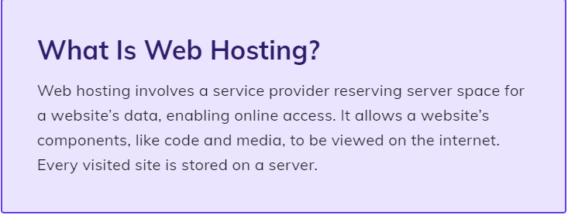

Web Testing:

Link: https://www.naukri.com/code360/library/introduction-to-web-testing

Having a professional and well-functioning website is the key factor in a successful website. Before presenting it to the end-user, it is important to ensure no bugs, errors, or technical faults exist that may degrade the website.

Web testing is a software practice that helps address errors, faults, and potential bugs of a web application that may go unnoticed by the developer.

Web testing is a software practice that ensures the quality of the given website by testing whether it is functioning correctly as intended or not. It checks for bugs and errors in the website that can arise before it is made available to the end-user.

Web testing allows developers to ensure that the web system works efficiently and provides the best user experience.

### Common issues that occur during web-testing

* Content
* Hyperlinks
* Site's layout
* Supported on different browsers
* Loading time for various features present on the website
* Functions
* Supported on multiple operating systems
* Check the login functionality

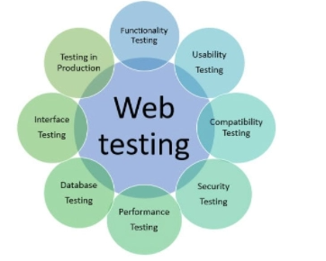

## Types of Web Testing

### **1. Functionality Testing**

We split the testing stage into two parts: front-end and back-end testing. This division helps in understanding the potential redevelopment quickly and accurately.

#### **Front-end testing**

It's concerned with testing the web application from the user's perspective. It includes testing the page's formatting, content, functionalities, checking if different links and forms attached to the website are working correctly. It also limits the validation tags for HTML, Javascript, etc.

#### **Back-end testing**

It's concerned with testing the web application from the developer's perspective. It includes testers sending requests directly to the server without using the user interface to isolate specific requests and look at the data structures.

***Functionality testing can be done manually or automated.***

***Tools used for functionality testing are IBM rational function tester, Selenium, QTP/UTP, etc.***

### **2. Performance Testing**

The next step is to check the performance of the web application. It should be operative irrespective of the user’s browser and operating system. It can be divided into various stages:

#### **Load Testing:**

The simplest form of testing conducted to understand the system's behavior under a specific load. Load testing is used to test how a website reacts when put under multiple users requests and simultaneous connections. It is done by creating virtual users that interact with the application in various ways using automated test scripts. The tester records results that can lead to any slowdowns in the application when hit by bulky requests.

#### **Stress Testing:**

This testing is used to determine the breaking point of the website by putting it under stress and observing how well the website recovers from such crashes. It's done by adding users to the application to the point where it fails and becomes unresponsive. The tester then records the total time taken by the website to recover from the crash. In this way, one can test the limit and efficiency of the website.

**Spike Testing:**

It works similar to load testing, where many users are added to the website. It is done to check the application's stability and ensure that it can handle expected and unexpected requests in certain instances.

**Soak Testing**

It is done to check the endurance of the website. During this testing, the parameters such as memory utilization are tested to detect any memory leak or any other performance issue that might occur. Many users are added to the website in this testing, and then the application is left to run for an extended period. Although a user rarely interacts with the application for an extended period, any unexpected error may occur if an application is pushed beyond what it was designed for. This testing helps catch those unforeseen issues before presenting the website to the end-user.

***Tools used to perform performance testing are Loadrunner, JMeter***.

### **3. Security Testing**

Security is one of the essential components of a website. A website that uses sensitive information like bank details, aadhar details, or other confidential information must ensure that the user data is protected from unauthorized access or data thefts. Security testing helps in finding issues, potential vulnerabilities and ensures maximum safety of the user's information. It involves validating login credentials, session timeout after a prolonged period, validating captchas, etc.

It can be done using techniques like injection, security configuration, broken authentication, session management invalidating redirects and forwards, sensitive data exposures, etc

.

***Tools used to perform security testing are CROSS, Babel Enterprises.***

### **4. Compatibility testing**

It ensures that the given website is compatible with various devices, browsers, and operating systems. It is essential to test that an application works flawlessly across all options available to the user. This is done by breaking the process into three stages:

#### **Browser Compatibility**

This includes checking whether all the authentication requests, browser notifications are functioning correctly. All the tests must be conducted on all the versions of the browsers available.

#### **Operating System Compatibility**

Similar to browser compatibility, operating system compatibility should be done on all the versions of OS available: Linux, Windows, macOS, etc., as a different OS, can render web elements differently, and that may affect the formatting, text fields, or buttons.

#### **Mobile Compatibility**

As most users prefer mobile devices to use a web page, it is important to ensure that the web application is supported on different devices available.

***Tools used to perform compatibility testing is NetMechanic.***

### **5. Usability testing**

This part of testing involves functional testing and improving the user's experience. A specific group of testers does it. It also checks for the validity of the content, grammatical errors, and ease of use.

It typically involves the following steps:

* Checks the content written on the website and ensures that all the functions and navigations are correctly done.
* Recruiting testers. They will help in preventing the website against different parameters.
* Analyzing the results and making proper amendments to the application.

***Tools used to perform the usability testing chalk mark, ClickTale, and feedback army***.

### **6. Interface testing:**

This testing helps in checking the communication process and ensuring that errors are displayed correctly to be amended efficiently. It is done to measure the ability of the site to deal with the interruptions from both users’ and servers’ points of view.

The main interface servers are: web server, application server, and database server that needs to be tested, and this testing ensures that all these interfaces are interacting properly and generating no errors.

#### **Application server testing**

It involves sending a request to the database and making sure that output at the client side is displayed as intended.

#### **Web server testing**

It involves checking whether the webserver is handling all the requests properly or not.

#### **Database server testing**

It involves handling the output from the database. The output should match with the intended result of the user.

***Tools can be used to perform interface testing AlertFox, Ranorex***.